Data Visualizations

|  |  |
| --- | --- |
| Technology : | Data Analytics |
| Team ID : | PNT2022TMID51381 |
| Project Name : | Analytics for Hospitals' Health-Care Data |

TOPICS

1. Number Of Patients By Ward Types
2. Dashboard To Show Number Of Patients
3. Age Wise Patients With Department And Severity Filters
4. Dashboard With Hierarchy Bubble And Radial Visuals
5. Dashboard Showing Pie, Stacked Bar, Waterfall And Pie Charts

# 1) Number Of Patients By Ward Types

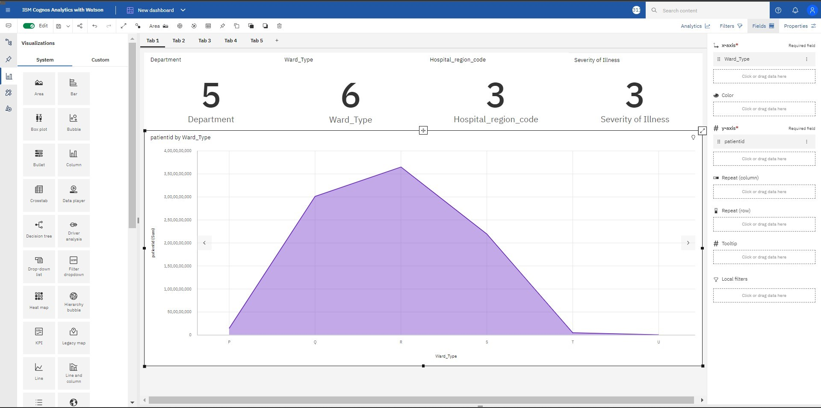

# 2) Dashboard To Show Number Of Patients

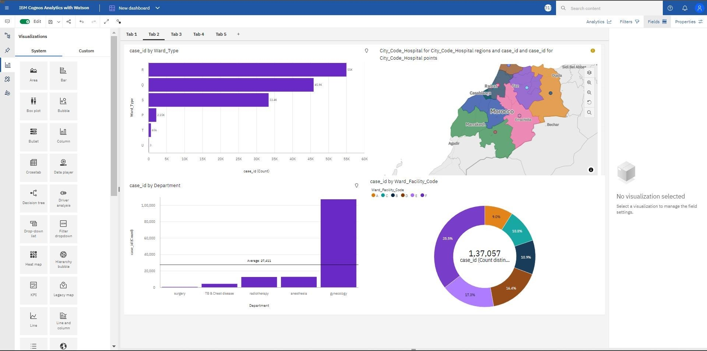

3) Age Wise Patients With Department And Severity Filters

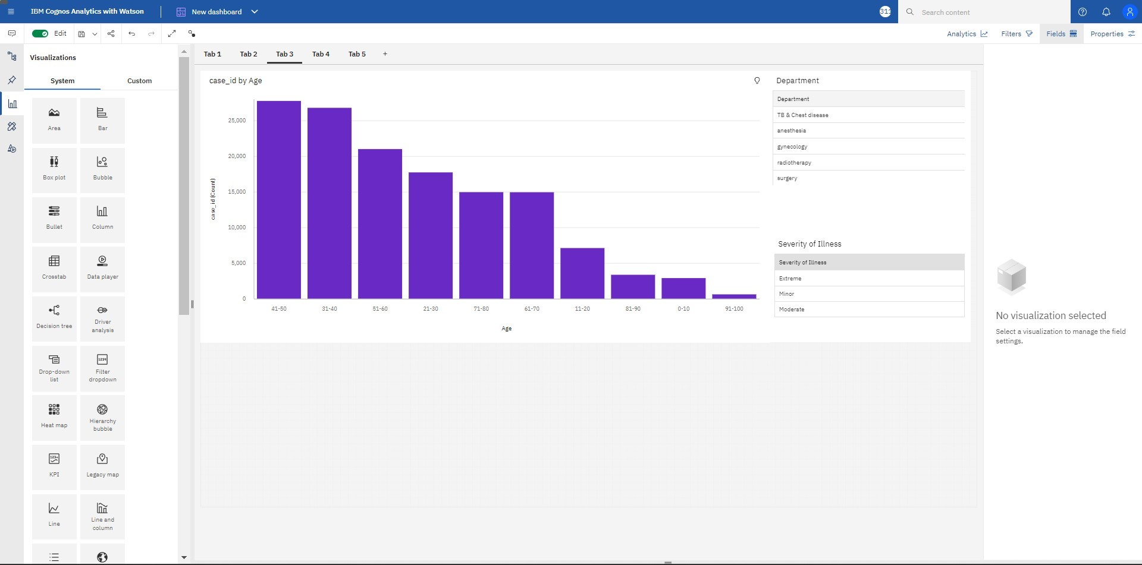

# 4) Dashboard With Hierarchy Bubble And Radial Visuals

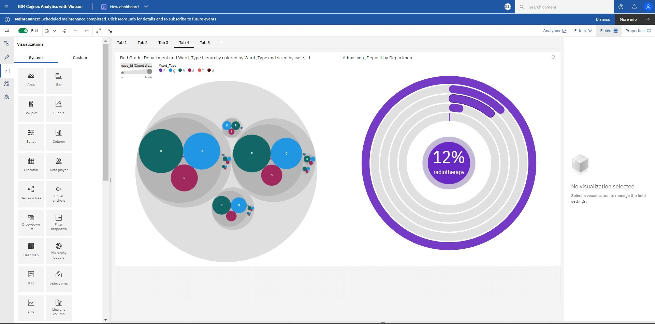

## 5) Dashboard Showing Pie, Stacked Bar, Waterfall And Pie Charts

